What is Node.js?
Node.js is an open-source, cross-platform JavaScript runtime environment that allows developers to execute JavaScript code outside of a web browser

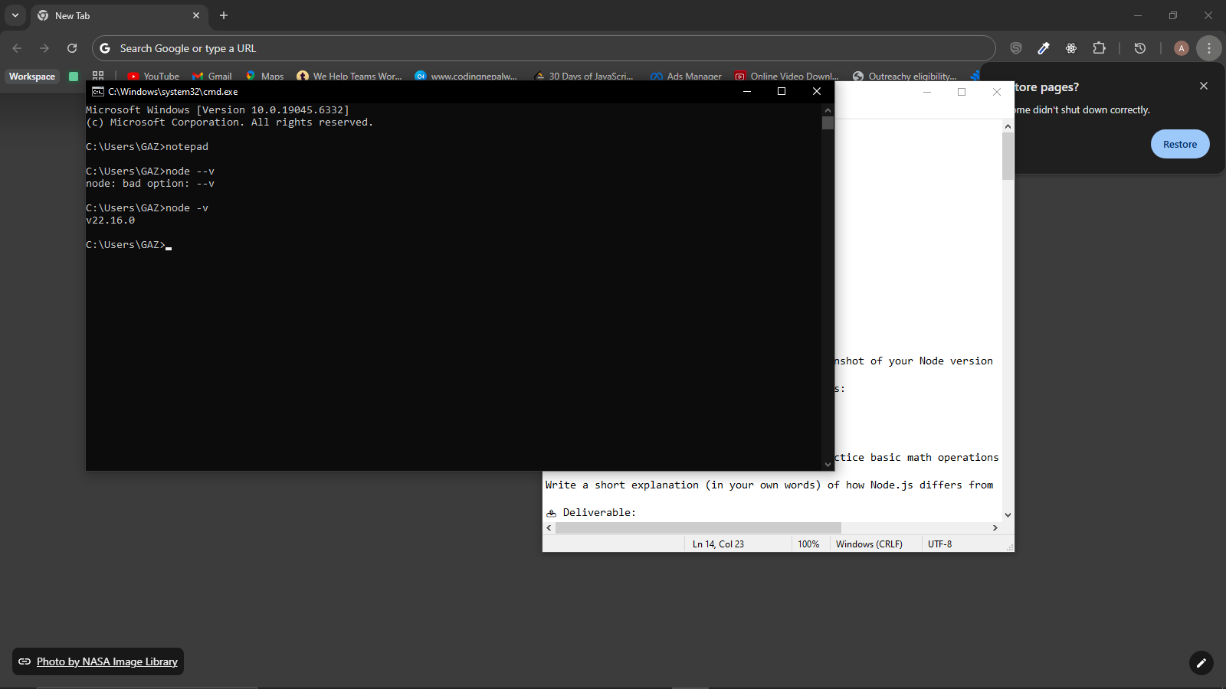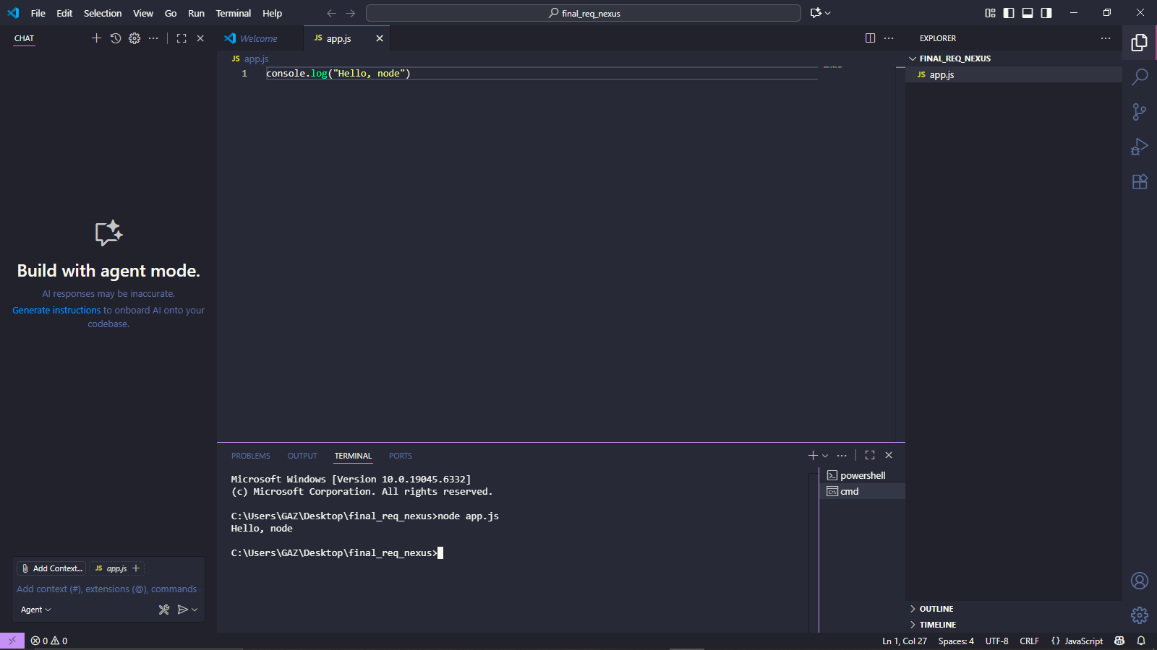

Write a short explanation (in your own words) of how Node.js differs from traditional web technologies like PHP:
That's a great question! The fundamental difference between Node.js and traditional web technologies like PHP comes down to their concurrency models—how they handle multiple user requests at the same time.

